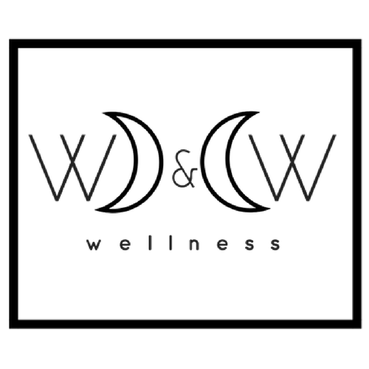
Wax and Wane Wellness LLC - Kelly Sherman L.Ac., CHN

Informed Consent to Acupuncture and Classical Chinese Medicine
Treatment and Care

I hereby request and consent to the performance of acupuncture treatments and other Classical Chinese Medicine techniques and adjunctive therapies on me (as listed below), or the patient named below, for whom I am legally responsible, by Kelly Sherman L.Ac., CHN, Wax and Wane Wellness LLC.
I understand that methods of treatment may include, but are not limited to, acupuncture, moxibustion, cupping & gua sha, essential oils, electro-acupuncture, Teishin, Tui-Na (Chinese massage), Chinese or western herbal medicine, and nutritional counseling. I have been informed that acupuncture is a safe method of treatment, but that it may have side effects, including bruising, numbness or tingling near the needling sites that may last a few days, and dizziness or fainting. Highly unusual risks of acupuncture include spontaneous miscarriage, nerve damage and organ puncture, including lung puncture (pneumothorax), although the acupuncturist named above has undergone rigorous studies and training to avoid these at all costs. Infection is a possible risk, although the acupuncturist named above uses sterile disposable needles and maintains a clean and safe environment. I understand that I should not make significant movements while the needles are being inserted, retained, or removed. One side-effect of cupping and gua sha may be temporary skin discoloration, called “sha.” Small, clear, blister-like phenomena may also occur as a result as a result of cupping therapy. Should this occur, I understand my acupuncturist will provide me with the proper information to care for them until they resolve. Burns and/or scarring are a potential risk of direct moxibustion, although the acupuncturist named above has undergone rigorous studies and training to avoid these at all costs. I understand that essential oils applied topically may cause skin irritation and photosensitivity. I will alert my acupuncturist to any known adverse reactions to topical essential oil usage and be mindful to wear sunscreen in the 24 hour period after treatments where essential oils were used topically on my skin. I understand that while this document describes the major risks of treatment, other side effects and risks may occur.
The herbs and nutritional supplements (which are from plant, mineral, and animal sources) that have been recommended are traditionally considered safe. I understand that some herbs may be inappropriate during pregnancy. Some possible side effects of taking herbs are nausea, gas, stomachache, vomiting, headache, diarrhea, rashes, hives and tingling of the tongue. I understand that the herbs need to be consumed according to the instructions provided orally and/or in writing. I will immediately notify the acupuncturist of any effects associated with the consumption of the herbs.
I will notify the acupuncturist who is caring for me if I am or become pregnant, or I have a bleeding disorder. I will notify the acupuncturist of any significant changes in my health, or new diagnoses by my primary medical physician. I understand that my acupuncturist encourages me to see a primary medical physician in conjunction with acupuncture and herbal treatments. I do not expect the acupuncturist to anticipate and explain all possible risks and complications of treatment, and I wish to rely on the acupuncturist to exercise judgment during the course of treatment. I understand that results are not guaranteed. I understand that a course of treatment may be recommended, and that if I do not follow the treatment plan, treatment outcomes may be affected.

I understand that I may ask my practitioner questions about each modality. I understand that I may stop the treatment if it is too uncomfortable. I understand that there may be other treatment alternatives, and that I may be referred to other medical professionals when appropriate.

Recommendation for Examination by a Physician

Virginia law requires that our clinic give this form to you if we do not have written evidence that you have received a diagnostic exam in the last six months from a licensed practitioner of medicine, osteopathy, chiropractic or podiatry regarding the condition for which you are seeking treatment. (Code of Virginia §54.1-2956.9, 18 VAC 85-110-10). Acupuncturists are regulated by the Virginia Medical Board, who require that we recommend that you see a physician if you have not within the last six months. This regulation is to your benefit, so that you will not need to get a physician’s referral to see an acupuncturist. Acupuncturists cannot be your primary care physician.

* As a patient of Wax and Wane Wellness LLC, I understand this recommendation. I have seen an appropriate medical practitioner (MD, osteopath, chiropractor, or podiatrist) in the last six months. If I have not, I commit to seeing one for this condition when it is medically necessary for me to do so.
By voluntarily signing below I show that I have read, or have had read to me, this consent to treatment, have been told about the risks and benefits of acupuncture and other procedures, have acknowledged my recommendation for examination by a physician, and know I will have the opportunity to ask questions. I intend this consent form to cover the entire course of treatment for my present condition and for any future condition(s) for which I seek treatment.

_______________________________________________________________________
Printed Name of Patient Date

_____________________________________________________
Signature of Patient (or Representative*)

_____________________________________________________
Printed Name of Patient Representative*
* Note: Patient Representative should sign if patient is a minor, or otherwise unable to sign for him or herself.

