Wax and Wane Wellness LLC - Kelly Sherman L.Ac., CHN

New Patient Health History + Initial Intake

Legal Name_____________________________________ Preferred Name____________________
Address_________________________________________________________________________
City________________________ State_______________________ Zip Code_________________
Age________DOB________________ Preferred gender + Pronoun__________________________
Best Phone # ____________________________ May we leave a message? __________________
Email___________________________________________________________________________
Do you prefer phone or email contact?_________________________________________________

Marital Status _____________________________________________________________________
Emergency Contact_____________________________________Phone #______________________
Emergency Contact relationship to you_________________________________________________
Are you currently under the care of a Primary Care Physician? Yes No
If yes, please provide the doctor’s name and clinic name___________________________________

How did you hear about Kelly Sherman L.Ac., CHN / Wax and Wane Wellness? Please circle one below:
- Wax and Wane Wellness Website/ Instagram/ Facebook?
- Bod Wellness Collective Website/Instagram/Facebook?
- Other? _____________________________________

What are your most important health concerns/areas you’d like to focus on during our visits? Please list in order of importance.
- ___________________________________________________________________________
- ___________________________________________________________________________
- ___________________________________________________________________________
- ___________________________________________________________________________
- ___________________________________________________________________________

General Information
Significant Traumas (auto accidents, falls, etc.)___________________________________________
________________________________________________________________________________

Please list any prescription medications, over the counter medications, vitamins, or supplements you are currently taking or have taken within the past 2 months and the reason for taking them:
- _______________________________ 4. _______________________________
- _______________________________ 5. _______________________________
- _______________________________ 6. _______________________________

Do you have allergies? If yes, what kind?
Drugs____________________________________________________________________
Foods____________________________________________________________________
Environmentals_____________________________________________________________

Personal History: Please circle any conditions or symptoms you have now or ever have had.

Arthritis  Heart Attack  Cancer  Ulcer  Chronic Fatigue  Alcoholism  Gastritis/ Pancreatitis | Liver/Gallbladder Dz.  Hypo/Hyperglycemia  Diabetes  Autoimmune Disorder  Anemia  Eating Disorder  Epilepsy/Seizures | Stroke  Kidney Dz/ stones  Impotence  Hepatitis  Thyroid Imbalance  Chronic Pain  Prolapsed Organ | Heart Disease  High Cholesterol  Diverticulitis  Raynaud’s Disease  Blood Clotting Disorder  HIV+  Emphysema  Fainting
Do you have a pacemaker? Y N
Any other serious health conditions?___________________________________________________

Please Circle if you currently have or have had any of these conditions below in the last 6 months:

General
Poor Appetite  Chills  Cravings  Bleed/Bruise easily  Muscle weakness/fatigue | Poor Sleep  Night Sweats  Localized Weakness  Weight loss  Weight gain | Fatigue  Sweat Easily  Poor Balance  Peculiar taste in mouth  Hot flashes | Sudden energy drop  Change in appetite  Fevers  Tremors  Dental/gum problems
Skin and Hair
Rashes  Eczema/Psoriasis  Skin discoloration  Greasy hair  Dry hair | Ulcerations  Dandruff  Acne  Warts  Oils skin | Hives/Allergic Dermatitis  Loss of hair  Change in skin/hair texture  Fungal infection  Dry skin | Itching  Recent moles  Face flushing  Weak nails  Ridged nails  Redness of skin
Head, Eyes, Ears, Nose, and Throat
Sinus Pain  Eye Strain  Dark circles under eyes  Ringing in ears  Nose bleeds  Sores on lips/tongue  Headaches | Difficulty swallowing  Eye pain  Eye dryness/itchiness  Cataracts  Poor hearing  Recurrent sore throat  Recurrent colds | Migraines  Poor vision  Blurred vision  “Floaters” in sight  Grinding teeth  Jaw clicks/locks | Glasses/contacts  Poor night vision  Earaches  Sinus congestion  Frequent sneezing  Frequent runny nose
Cardiovascular
Chest pain/ pressure  Cold hands/ feet  Shortness of breath  Heart murmur | Irregular heart beat  Swelling of hands/ feet  Varicose veins  Spontaneous sweating | Palpitations at rest  Blood clots  Pressure in chest  dizziness | Spider veins  Phlebitis  High blood pressure  Low blood pressure

Respiratory
Cough/ wheezing  Pneumonia | Coughing up blood  Pain with deep inhalation | Tightness in chest | Asthma

Gastrointestinal
Nausea  Gas  Indigestion  Bloating  Gurgling  IBS  Excessive hunger | Vomiting  Belching  Bad breath  Strong smelling stools  Acid reflux/ GERD  Frequent hiccoughing  “Sour” stomach | Diarrhea  Black stools  Rectal/anal pain  Loose stools  Hernia  Crohn’s Disease | Constipation  Blood/mucus in stools  Hemorrhoids  Abdominal pain/cramps  Sticky stools  Food in stools

Urinary
Pain with urination  Unable to hold urine  Impotence | Frequent urination  Cloudy urine  Sores on genitals | Blood in urine  Scanty urine flow  Dribbling after urination  Urinary Tract Infection(s) | Urgent urination  Copious flow of urine  Burning urination  Concentrated urine

Musculoskeletal
Neck pain  Knee pain  Hip pain  Back pain: low, mid, upper? | Shoulder pain  Frequent sprains/strains  Muscle pain/tension  Hand/ wrist pain  Sciatica | Heaviness of limbs  Heaviness of head  Rib side pain  Facial pain | Jaw pain/ TMJD  Areas of numbness  Heel pain  Foot/ankle pain
Neuropsychological
Poor concentration  Lack of coordination  Anxiety  Panic attacks  nervousness | Loss of balance  Poor memory  Memory loss  Bad temper/ rage | Vertigo  Concussion  Easily stressed  Bipolar | ADD/ADHD  Depression  Seasonal affective disorder  Irritability
For Men
Premature ejaculation  Nocturnal emission  Penal discharge | Fatigue after ejaculation  Pain in testicles  Varicocele | Prostatitis  Testicular mass | Infertility  STD _______________

Gynecological/ Reproductive (For Women)
Difficult/Painful Intercourse  Vaginal dryness  Vaginal sores  Vaginal discharge  Vaginal itching/burning  Frequent vaginal infections  Irregular menstruation  Pelvic adhesions/scarring  Pelvic pain  Breast pain | Ovarian cysts  Endometriosis  Uterine fibroids/polyps  Fibrocystic breast tissue  Polycystic Ovarian Syndrome  Nipple discharge  Pelvic/tubal infection  Infertility  STD________________ | Date of last PAP ____________  Abnormal PAP? When?_______  Number of Pregnancies ________  Number of Births_____________

Age of first menses___________
Date of last menses____________ Recent menstrual changes?_______________________________
Do you experience spotting between periods?______________________________________________
Do you have PMS symptoms? Pain, Irritability, Fatigue, Anxiety/Depression?___________________
__________________________________________________________________________________

Do you use birth control? ________ What type?___________________ How long?______________

If currently pregnant, how far along?____________________________________________________
Are you attempting pregnancy currently? If so, for how long?________________________________

Menopausal symptoms?_______________________________________________________________
Any other menstrual or reproductive concerns?______________________________________________

Nutritional Evaluation
List some of your favorite foods or foods that you crave: ____________________________________________________________________________________
List any known food sensitivities, allergies or foods that otherwise disagree with you: ____________________________________________________________________________________
Are you currently on any kind of special diet or adhere to a particular food philosophy? yes / no…. Please explain: ______________________________________________________________________________

Do you use:
Alcohol? yes / no
Tobacco? yes / no
Recreational drugs/medications? yes / no
How many glasses of water do you drink a day? _____________________
Do you react to any chemicals, cosmetics, household cleaners, smoke, fabrics, etc? ____________
If yes please list: _________________________________________________________________

Lifestyle Evaluation
Occupation: _______________________________________________________________________________
What are your hobbies/interests? _______________________________________________________________
What would you say are your main stressors? _____________________________________________________
__________________________________________________________________________________________
On a scale from 1 – 10 (1 being none and 10 being very extreme) what is your current level of stress? ______
Is your energy level: ___ high ___ low ___ up and down?
What do you do for exercise?:_________________________________________________________________
How many hours do you sleep at night? _________________ Usual bedtime? __________________________
Usual time you get up? _________________ Do you feel rested when you get up? _______________________

PLEASE MARK YOUR AREAS OF CONCERN

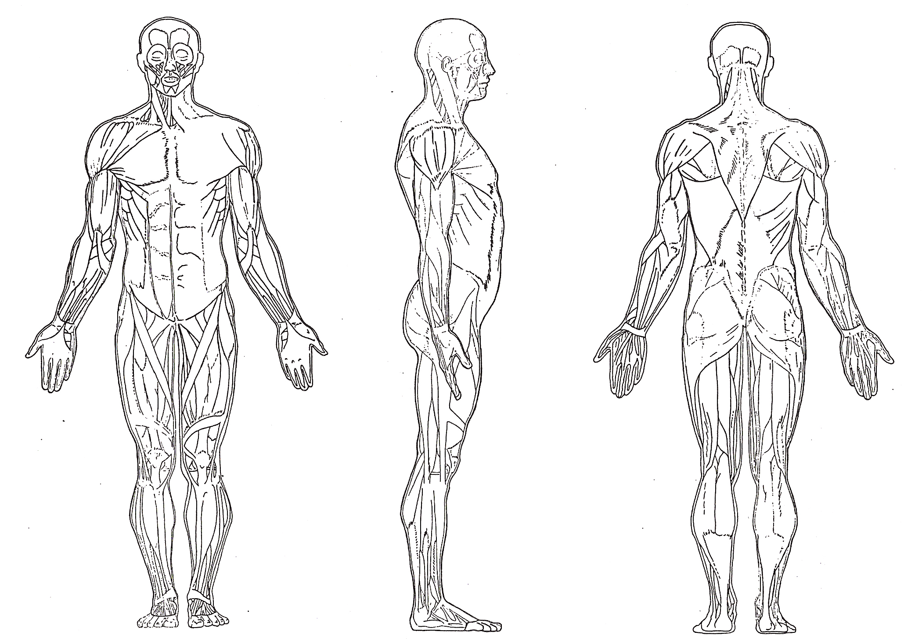

Consents and Acknowledgement: Full length forms available to review at www.waxandwanewellness.com

1)I have carefully read, understand, and give my consent for Acupuncture and Classical Chinese Medicine treatment from Kelly Sherman L.Ac. of Wax and Wane Wellness LLC. I understand that I may ask my practitioner for a more detailed explanation at any time.

2) I have been given an opportunity to read and I acknowledge and agree to Wax and Wane Wellness LLC’s Privacy and Sharing of Information Policy as required by HIPAA.

3) I acknowledge Wax and Wane Wellness LLC’s recommendation in accordance with Virginia law for examination by a physician in conjunction with my acupuncture care.

4) I have read and agree to the Wax and Wane Wellness LLC @ Bod Wellness Collective Office Policies.

_______________________________________________________________________
Printed Name of Patient Date

_____________________________________________________
Signature of Patient (or Representative*)

_____________________________________________________
Printed Name of Patient Representative*
* Note: Patient Representative should sign if patient is a minor, or otherwise unable to sign for him or herself.

